

CAPSTONE PROJECT REPORT
Report 3 – Software Requirement Specification

– Ho Chi Minh, August 2026 –
Table of Contents
I. Project Report 3
1. Status Report 3
2. Team Involvements 3
3. Issues/Suggestions 3
II. Software Requirement Specification 4
1. Overall Description 4
1.1 Product Overview 4
1.2 Business Rules 5
2. User Requirements 6
2.1 System Actors 6
2.2 Use Cases 6
3. Functional Requirements 8
3.1 System Functional Overview 8
3.2 <<Feature Name 1>> 10
3.3 <<Feature Name 2>> 10
4. Non-Functional Requirements 11
4.1 External Interfaces 11
4.2 Quality Attributes 12
5. Other Requirements 14
5.1 Appendix1 - Messages List 14
5.2 Appendix2 - … 14
5.3 … 14

I. Record of Changes
Date | A*  M, D | In charge | Change Description
24/06/2026 | A | Team | Initial draft of Software Requirement Specification
*A - Added M - Modified D - Deleted

II. Software Requirement Specification

1. Product Overview
FengDesk AI is an e-commerce platform that combines an AI-powered recommendation engine with a multi-vendor e-commerce marketplace specializing in feng shui plants for personal workspaces. The platform replaces the current fragmented experience — where users rely on subjective, generic feng-shui advice from one channel and then purchase plants from unrelated stores — with a single, data-driven, recommendation-to-purchase journey.
Unlike conventional plant e-commerce sites, FengDesk AI personalises every suggestion using two complementary signals. First, a rule-based feng-shui engine derives the customer’s destiny element (Five elements: Metal, Wood, Water, Fire, Earth) from their birth year and filters the in-stock catalogue to elementally compatible plants. Second, a generative AI vision step sends the customer’s real desk photo together with that filtered list to the Gemini Vision API, which analyses lighting, available area and working purpose to rank the most suitable plants and produce a human-readable explanation (Explainable AI).
The platform further differentiates itself with on-demand 3D previews — garden owners upload a 2D product photo that is converted into a 3D model through the Meshy.ai API so customers can inspect a plant before buying — and with a true marketplace model in which a single shopping cart is automatically split into independent sub-orders routed to each responsible garden. The context diagram below illustrates the boundary of the system and the external entities (human actors and third-party services) that interface with it.
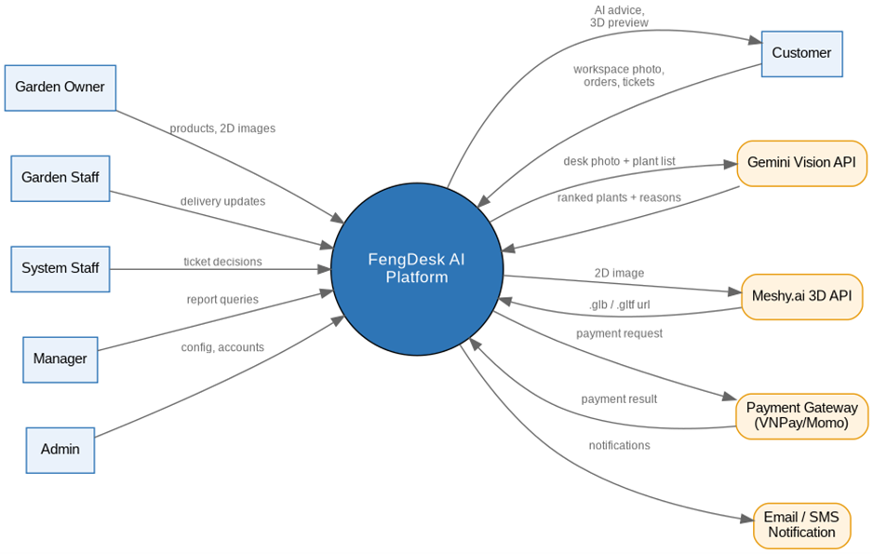
Figure 1. FengDesk AI – System Context Diagram

2. User Requirements

2.1 Actors

# | Actor | Description
1 | Customer | An end user who builds a feng-shui profile, uploads a workspace photo to obtain AI plant recommendations, browses the catalogue with 3D preview, places and pays for orders, tracks delivery, and raises support tickets for living-plant issues
2 | Garden Owner | A vendor (nursery owner) who manages a garden store, performs full product management (price, description, images, stock, element), requests 2D-to-3D model generation, manages orders routed to the garden and assigns them to garden staff, and views the garden’s own sales reports.
3 | Garden Staff | An employee of a garden who receives assigned orders, prepares and packages plants, performs local delivery, and updates delivery progress (prepared, shipped, delivered).
4 | Staff (System Staff) | A platform operator who monitors all orders across the system and resolves customer support tickets by approving a refund or an exchange; an approved exchange automatically generates a new zero-value order to the originating garden.
5 | Manager | A regional manager who supervises overall operations, monitors fulfilment and delivery KPIs, and generates system-wide revenue and performance reports.
6 | Admin | A system administrator who manages all user accounts, roles and permissions, maintains the global plant database and categories, configures AI recommendation parameters, and monitors system logs and security.

2.2 Use Cases

2.2.1 Diagram(s)
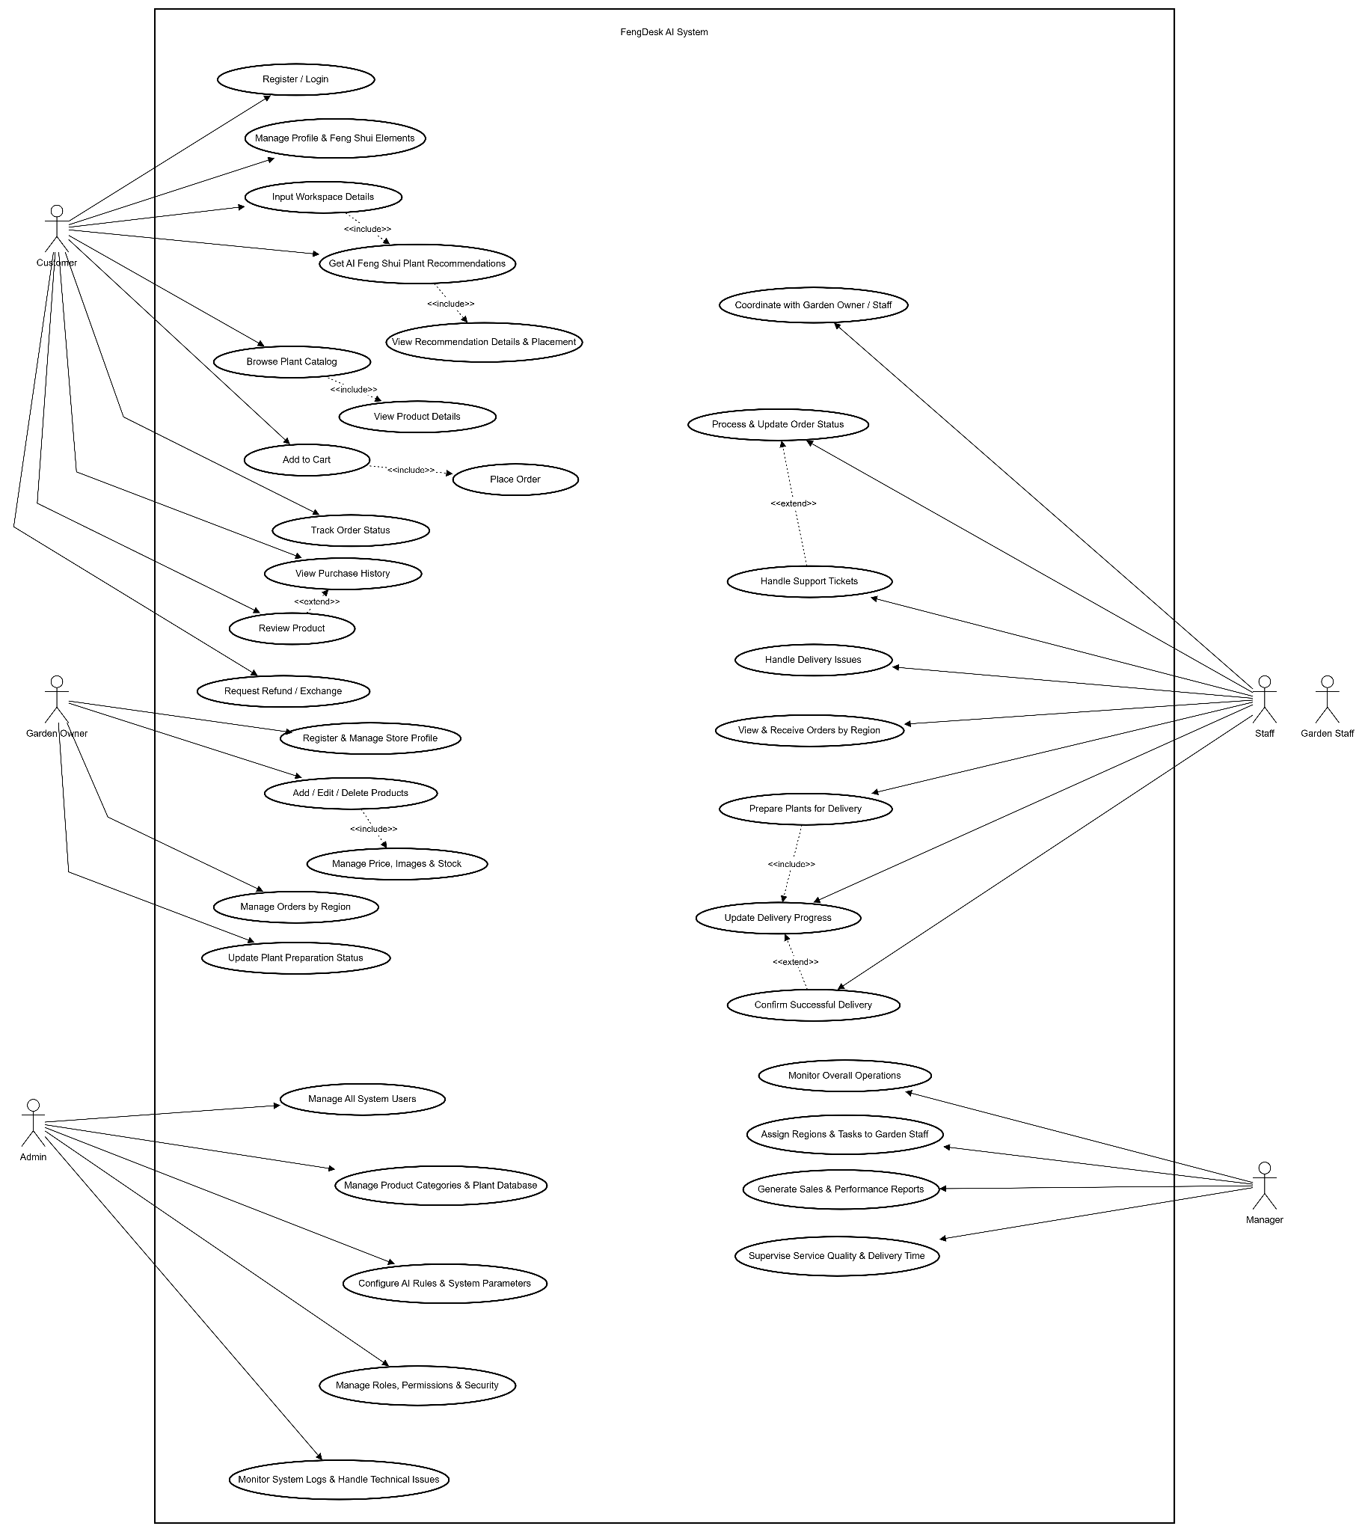
Figure 2. FengDesk AI – Use Case Diagram

2.2.2 Descriptions
This part describes the use cases, you can follow the table form as below]
ID | Use Case | Actors | Use Case Description
UC-01 | Register / Login | Customer (all roles) | Register a new account and authenticate to access role-based features.
UC-02 | Manage Profile & Birth Year | Customer | Maintain personal profile and birth year, from which the destiny element (Five Elements) is derived.
UC-03 | Upload Workspace Photo & Details | Customer | Upload a real desk photo and declare lighting, desk area and working purpose for AI analysis.
UC-04 | Get AI Feng Shui Recommendation | Customer | Run the hybrid engine (rule-based element filter + Gemini Vision) to obtain ranked, compatible plants.
UC-05 | View Recommendation & Placement | Customer | View recommended plants with explanation (Explainable AI) and suggested desk placement.
UC-06 | Browse Plant Catalog | Customer | Browse and search the plant catalogue.
UC-07 | View Product Details | Customer | View product information, price, stock and element.
UC-08 | View 3D Preview | Customer | Rotate and zoom the interactive 3D model (.glb/.gltf) before purchase.
UC-09 | Add to Cart | Customer | Add products from one or more gardens to a single cart.
UC-10 | Checkout & Split Order | Customer | Check out the cart; the system automatically splits it into one sub-order per garden.
UC-11 | Make Payment | Customer | Pay the whole order group in a single transaction via the payment gateway.
UC-12 | Track Order Status | Customer | Track the status and delivery progress of each split order.
UC-13 | View Purchase History | Customer | View the history of past orders.
UC-14 | Review Product | Customer | Optionally rate and review a purchased product.
UC-15 | Request Refund / Exchange | Customer | Raise a support ticket for a wilted/dead plant with photo evidence.
UC-16 | Register & Manage Store Profile | Garden Owner | Register and maintain the garden store profile, including region. .
UC-17 | Add / Edit / Delete Products | Garden Owner | Perform full CRUD on the garden's plant products.
UC-18 | Manage Price, Images & Stock | Garden Owner | Maintain price, product images, stock level, element and category.
UC-19 | Generate 3D Model (Meshy) | Garden Owner | Submit a 2D product image to Meshy.ai; the system polls the task and stores the 3D model URL.
UC-20 | Manage Orders by Region | Garden Owner | View and manage the split sub-orders routed to the garden.
UC-21 | Assign Order to Garden Staff | Garden Owner | Assign a routed sub-order to a garden staff member for fulfilment.
UC-22 | View Garden Sales Report | Garden Owner | View revenue and fulfilment reports scoped to the own garden.
UC-23 | View & Receive Assigned Orders | Garden Staff | View and accept sub-orders assigned within the region
UC-24 | Prepare & Package Plants | Garden Staff | Prepare, package and label plants for local delivery.
UC-25 | Update Delivery Progress | Garden Staff | Update delivery status (prepared, shipped, delivered).
UC-26 | Confirm Successful Delivery | Garden Staff | Confirm successful delivery within the assigned area.
UC-27 | Monitor All Orders System-wide | Staff | Monitor all orders and tickets across gardens and regions.
UC-28 | Process Support Tickets | Staff | Review a living-plant complaint and decide the resolution.
UC-29 | Issue Refund | Staff | Approve a monetary refund for the affected items.
UC-30 | Create Exchange Order (0 VND) | Staff | Auto-create a new zero-value order to the originating garden; the dead plant is not recalled.
UC-31 | Coordinate Delivery Issues | Staff | Coordinate with gardens to resolve delivery problems.
UC-32 | Monitor Overall Operations | Manager | Supervise overall system operations and fulfilment.
UC-33 | Assign Regions & Tasks | Manager | Assign regions and operational tasks across gardens/staff.
UC-34 | Generate Sales & Performance Reports | Manager | Generate system-wide revenue and performance reports.
UC-35 | Supervise Service Quality & Delivery Time | Manager | Monitor service-quality and delivery-time KPIs.
UC-36 | Manage All System Users | Admin | Create, update and lock all user accounts.
UC-37 | Manage Categories & Plant Database | Admin | Maintain product categories and the global plant database.
UC-38 | Configure AI Rules & Parameters | Admin | Configure element-compatibility rules, scoring weights and Gemini parameters.
UC-39 | Manage Roles, Permissions & Security | Admin | Manage roles, permissions and system security settings.
UC-40 | Monitor System Logs & Technical Issues | Admin | Monitor system logs and handle technical issues.

3. Functional Requirements

3.1 System Functional Overview

3.1.1 Screens Flow
The screen-flow diagram shows the navigation between the main screens of FengDesk AI, grouped by the customer journey, the garden back-office, and the platform back-office. Screens highlighted in amber (Product Detail with 3D viewer and 3D Generation) involve the Meshy.ai integration.

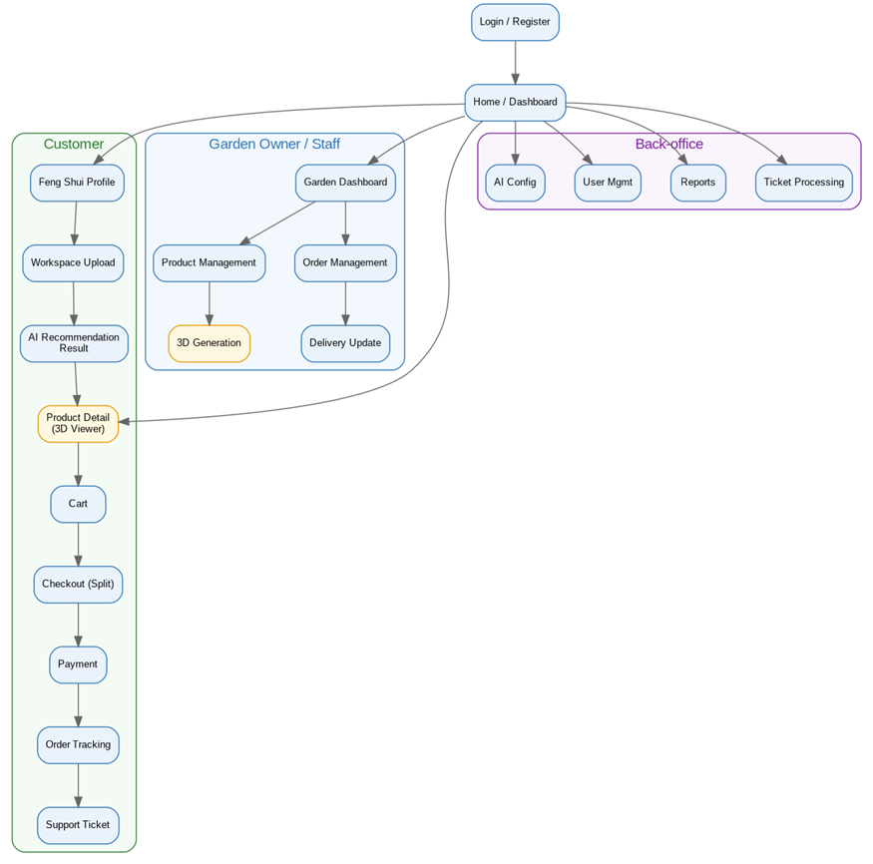
Figure 3. FengDesk AI – Screens Flow

3.1.2 Screen Descriptions

# | Feature | Screen | Description
1 | Account | Login / Register | Authenticate users and register new customers/gardens; collect birth year for customers.
2 | Feng Shui | Feng Shui Profile | Show derived destiny element and elemental compatibility; let the customer review/update profile.
3 | AI Recommendation | Workspace Upload | Upload desk photo and declare lighting, desk area and working purpose.
4 | AI Recommendation | AI Recommendation Result | Display ranked plants with explanation and suggested placement; link to product details
5 | Catalogue | Product Detail (3D Viewer) | Show product information, price, stock and an interactive 3D model rendered with model-viewer/Three.js.
6 | Shopping | Cart | Review selected products across multiple gardens before checkout
7 | Shopping | Checkout (Split) | Confirm shipping info; system previews the split into per-garden sub-orders and the total.
8 | Shopping | Payment | Redirect to the payment gateway and return the payment result.
9 | Order | Order Tracking | List the customer’s order groups and each split order with delivery status
10 | Support | Support Ticket | Create and track refund/exchange tickets with photo evidence
11 | Garden | Garden Dashboard | Overview of the garden’s products, orders and KPIs for the owner.
12 | Garden | Product Management | CRUD products, stock and images; assign element and category
13 | Garden | 3D Generation | Upload a 2D image, submit to Meshy.ai and monitor the generation job.
14 | Garden | Order Management | View routed orders and assign them to garden staff.
15 | Garden | Delivery Update | Garden staff update preparation and delivery progress.
16 | Back-office | Ticket Processing | Staff review tickets and approve refund or exchange.
17 | Back-office | Reports | Manager views revenue, fulfilment and service-quality reports.
18 | Back-office | User Management | Admin manages accounts, roles and permissions.
19 | Back-office | AI Config | Admin configures element rules, scoring weights and Gemini parameters.

3.1.3 Screen Authorization
The matrix below maps system roles to screen access. “X” indicates the role can access the screen or perform the activity. CU = Customer, GO = Garden Owner, GS = Garden Staff, ST = Staff, MG = Manager, AD = Admin.

Screen / Activity | CU | GO | GS | ST | MG | AD
Login / Register | X | X | X | X | X | X
Feng Shui Profile | X
Workspace Upload & AI Recommendation | X
Product Detail (3D Viewer) | X | X | X | X | X | X
Cart / Checkout / Payment | X
Order Tracking (own) | X
Screen / Activity | CU | GO | GS | ST | MG | AD
Support Ticket (create) | X
Garden Dashboard |  | X
Product Management |  | X
3D Generation |  | X
Order Management (assign) |  | X
Delivery Update |  |  | X
Ticket Processing (refund/exchange) |  |  |  | X
Monitor All Orders |  |  |  | X | X
Reports (system-wide) |  |  |  |  | X
Reports (own garden) |  | X
User & Permission Management |  |  |  |  |  | X
AI Parameter Configuration |  |  |  |  |  | X
Query All Data |  |  |  | X | X | X
Query Own Data | X | X | X
Query Managed Data |  | X |  |  | X

3.1.4 Non-Screen Functions
Beyond interactive screens, FengDesk AI relies on several background services, API integrations and asynchronous jobs.
# | Feature | System Function | Description
1 | AI Recommendation | ElementCalculationService | Derive the customer’s destiny element from birth year (Can-Chi / nạp-âm rule) and resolve generating/overcoming relations.
2 | AI Recommendation | HybridRecommendationService | Filter in-stock plants by element compatibility, then call the Gemini Vision API with the desk photo and filtered list to rank plants and return explanations.
3 | 3D Generation | Meshy3DWorker | Submit a 2D image to Meshy.ai, poll the task until completion, and persist the resulting .glb/.gltf URL to the product.
4 | Order | SplitOrderService | On checkout, split a single cart into N sub-orders grouped by garden_id and create the order group.
5 | Payment | PaymentWebhookHandler | Receive the gateway callback, confirm the payment of the order group and release sub-orders to gardens.
6 | Support | ExchangeOrderGenerator | On an approved exchange, automatically create a new zero-value order to the originating garden without recalling the dead plant.
7 | Notification | NotificationService | Send transactional email/SMS for order, delivery, payment and ticket events.
8 | Reporting | ReportAggregationJob | Aggregate sales, fulfilment and delivery KPIs for manager and garden-owner dashboards.

3.1.5 Entity Relationship Diagram
[Provide the entity relationship diagram and the entity descriptions in the table format as below]
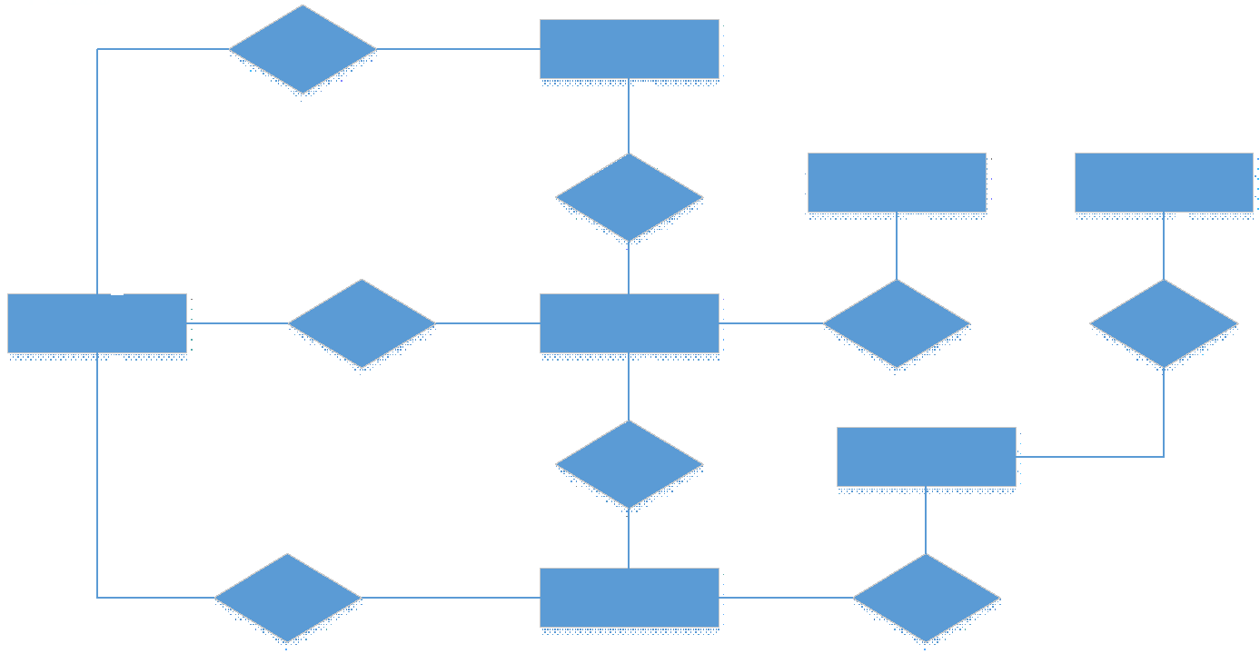
Entities Description
# | Entity | Description
1 | User
2 | Meal
3 | Meal Subscription
4 | …

3.2 AI Feng Shui Recommendation

3.2.1 Calculate Feng Shui Element
Function trigger: automatically invoked when a customer completes registration with a birth year, or when the birth year is updated on the Feng Shui Profile screen.
Function description: a non-screen rule-based service (ElementCalculationService) that converts the customer’s birth year into one of the five destiny elements and stores element_id on the user record. It also exposes the generating (tương sinh) and overcoming (tương khắc) relations used by downstream filtering.
Function details:
• Input: birth year (Gregorian). Validation: year must be a 4-digit value between 1900 and the current year.
• Processing: apply the Can-Chi / nạp-âm mapping rule to obtain the destiny element; persist element_id to users.
• Business rules: BR-01 governs element derivation; BR-02 governs which elements are considered compatible (same element or generating element).
• Abnormal case: if the birth year is missing or invalid, the customer is prompted to complete the profile and recommendation is blocked until resolved (message MSG-02).

3.2.2 Generate AI Recommendation (Hybrid)

Function trigger: the customer submits the Workspace Upload screen (desk photo + lighting + desk area + working purpose).

Function description: the HybridRecommendationService executes a two-stage pipeline and returns a ranked list of plants with explanations, persisted as a recommendation with recommendation_items.

Function details:

1. Stage 1 – Rule-based filter: select in-stock products whose element_id is compatible with the customer’s element (per BR-02), producing a candidate list.

2. Stage 2 – Generative AI: send the desk photo together with the candidate list to the Gemini Vision API; the model analyses lighting, available area and purpose, then ranks the most suitable plants and returns a reason for each (Explainable AI).

3. Persist the ranked items with score and reason; display them on the AI Recommendation Result screen with suggested placement.

• Business rules: BR-02 (compatibility), BR-03 (every recommendation must carry an explanation).

• Abnormal cases: if the candidate list is empty, fall back to a broader compatibility set and flag low confidence; if the Gemini API call fails or times out, return the Stage-1 ranked list with a notice that visual analysis was unavailable (message MSG-10).

3.2.3 View Explainable Recommendation

Function trigger: navigation from the recommendation result, or re-opening a past recommendation from history.

Function description: renders each recommended plant with its compatibility reason, the functional/lighting reason from the vision analysis, a suggested desk placement, and a direct link to the product detail (including 3D preview) and the cart.

3.3 3D Model Generation & Preview

3.3.1 Generate 3D Model (Meshy.ai)

Function trigger: a Garden Owner uploads a 2D product image on the 3D Generation screen and submits the generation request.

Function description: the Meshy3DWorker submits the image to the Meshy.ai API, records a model_3d_jobs entry, polls the task status, and on completion stores the .glb/.gltf URL into products model_3d_url.

Function details:

• Input: a single 2D image (JPEG/PNG). Validation: file type and maximum size; the product must belong to the requesting owner’s garden (BR-10).

• Processing: asynchronous polling; the job status transitions Pending → Processing → Completed/Failed.

• Abnormal case: on failure or timeout, the job is marked Failed and the owner may retry; the product simply shows no 3D preview until a model is available.

3.3.2 View 3D Preview

Function description: on the Product Detail screen, when model_3d_url is present, the customer can rotate and zoom an interactive 3D model rendered with model-viewer/Three.js before purchasing.

3.4 Order, Split-Order & Support Management

3.4.1 Checkout & Split Order

Function trigger: the customer confirms checkout from the Cart screen.

Function description: the SplitOrderService creates one order group for the whole cart and automatically splits the items into N sub-orders, one per distinct garden_id, each with its own subtotal.

Function details:

• A single cart may legitimately contain products from multiple gardens (BR-04).

• On checkout, the cart is split into one order per garden (BR-05); the order group total equals the sum of sub-order subtotals.

• Each sub-order is routed to its garden only after the order group payment succeeds (BR-06).

3.4.2 Make Payment

Function description: the customer pays the order group total in one transaction via the payment gateway; the PaymentWebhookHandler confirms the result and releases the split sub-orders to their gardens. The whole order group is paid with a single payment method (BR-06).

3.4.3 Support Ticket – Refund / Exchange

Function trigger: the customer creates a support ticket for a wilted/dead plant, attaching photo evidence, against a delivered order.

Function description: a Staff member reviews the ticket and resolves it as either a Refund or an Exchange. This flow is tailored to living organisms.

Function details:

• Photo evidence is mandatory and must be submitted within the claim window (BR-08).

• Refund: the staff approves a monetary refund for the affected items.

• Exchange: the ExchangeOrderGenerator automatically creates a new zero-value (0 VND) order to the originating garden (BR-07).

• The dead plant is never recalled — no plant corpse is returned (BR-09).

4. Non-Functional Requirements

4.1 External Interfaces
FengDesk AI communicates with users through responsive web screens (ReactJS/Next.js) and with the following external systems:
# | Interface | Type | Description
1 | Gemini Vision API | REST/HTTPS | Sends the workspace photo and filtered plant list; receives a ranked list and per-plant explanations.
2 | Meshy.ai API | REST/HTTPS (async) | Submits a 2D image and polls a generation task; returns a downloadable .glb/.gltf model URL.
3 | Payment Gateway (VNPay/Momo) | REST/HTTPS + Webhook | Initiates payment for the order group and receives the result via redirect and server callback.
4 | Email / SMS provider | REST/HTTPS | Delivers transactional notifications for orders, deliveries, payments and tickets.
5 | model-viewer / Three.js | Client-side library | Renders interactive 3D models in the browser from the stored model URL.

4.2 Quality Attributes

4.2.1 Usability
• The interface shall be intuitive for non-technical users; a first-time customer shall be able to complete the workspace-upload-to-recommendation flow without training.
• Every AI recommendation shall be accompanied by a plain-language explanation so the user understands why each plant was selected.
• The UI shall be responsive and usable on both desktop and mobile browsers.

4.2.2 Reliability
• Availability: the platform shall target at least 99.0% monthly uptime for core e-commerce operations.
• Order processing and payment confirmation shall be transactionally consistent; a confirmed payment shall always result in released sub-orders.
• Failure of an external AI/3D service shall degrade gracefully (fallback to rule-based results or hidden 3D preview) without blocking purchases.

4.2.3 Performance
• Catalogue browsing and product detail pages shall respond within ~2 seconds under normal load.
• The end-to-end AI recommendation (including the Gemini call) shall typically complete within ~10 seconds, with a visible progress indicator.
• 3D model generation is asynchronous; the customer-facing preview load shall not depend on generation time.

4.2.4 Security

• Authentication and role-based authorization shall protect every screen and API per the authorization matrix in section 3.1.3.

• Personal and payment-related data shall be transmitted over encrypted channels (HTTPS/TLS).

• Passwords shall be stored using a strong one-way hash; API keys for Gemini, Meshy and the payment gateway shall be kept server-side only.

4.2.5 Scalability & Maintainability

• The backend shall follow .NET Core Clean Architecture with modular, independently maintainable components (AI, e-commerce, user management).

• The system shall scale horizontally to support growing numbers of users, gardens, products and transactions without significant performance degradation.

• Data consistency shall be maintained across the recommendation, catalogue and order modules through a relational PostgreSQL schema with referential integrity.

5. Requirement Appendix

5. Requirement Appendix

5.1 Business Rules
ID | Rule Definition
BR-01 | A customer’s destiny element (Ngũ hành) is derived from the birth year using the Can-Chi / nạp-âm mapping rule.
BR-02 | A plant is considered feng-shui compatible if its element is the same as, or generates (tương sinh), the customer’s element.
BR-03 | Every AI recommendation item must include a human-readable explanation (Explainable AI).
BR-04 | A single shopping cart may contain products from multiple gardens.
BR-05 | On checkout, the cart is automatically split into one sub-order per distinct garden.
BR-06 | All sub-orders of one order group are paid together in a single payment with a single method; sub-orders are released to gardens only after payment succeeds.
BR-07 | An approved exchange automatically creates a new zero-value (0 VND) order to the originating garden.
BR-08 | A living-plant complaint must include photo evidence and be submitted within the defined claim window after delivery.
BR-09 | The platform does not recall the dead/wilted plant; no plant corpse is returned for a refund or exchange.
BR-10 | Only a Garden Owner may request 3D generation, and only for products belonging to that owner’s garden.
BR-11 | Only Admin may modify AI configuration parameters (element rules, scoring weights, Gemini parameters).
BR-12 | Stock is decremented upon successful payment; an out-of-stock product cannot be added to the cart at checkout.
BR-13 | Local delivery of a sub-order is performed only by garden staff of the garden that owns the sub-order.

5.2 Common Requirements

• All list screens shall support pagination, search and sorting.

• All create/update forms shall validate mandatory fields and display inline error messages before submission.

• All monetary values shall be stored and displayed in Vietnamese Dong (VND).

• All timestamps shall be recorded in the server time zone and displayed in the user’s locale.

5.3 Application Messages List
# | Code | Type | Context | Content
1 | MSG-01 | In line | No search result is found | No results found.
2 | MSG-02 | In red, under field | A required field is empty | This field is required.
3 | MSG-03 | Toast | A record is updated successfully | Updated successfully.
4 | MSG-04 | Toast | A new record is added successfully | Added successfully.
5 | MSG-05 | Toast | Order placed successfully | Your order has been placed.
6 | MSG-06 | Toast | Payment completed successfully | Payment successful. Your orders are being processed.
7 | MSG-07 | In line | Invalid birth year on profile | Please enter a valid birth year to calculate your element.
8 | MSG-08 | In red, under field | Input exceeds maximum length | Exceeds the maximum length of {max_length}.
9 | MSG-09 | In line | Wrong username or password at sign-in | Incorrect username or password. Please try again.
10 | MSG-10 | Toast (warning) | Gemini analysis unavailable | Visual analysis is temporarily unavailable; showing feng-shui-based results.
11 | MSG-11 | Toast | 3D generation job submitted | 3D model generation has started; it will appear when ready.
12 | MSG-12 | Toast | Support ticket submitted | Your ticket has been submitted and is under review.
13 | MSG-13 | Toast | Exchange approved | An exchange order has been created and sent to the garden.

